ENGLISH FIRST ADDITIONAL LANGUAGE
Grade 9 - 2011
Transactional Writing (20):
TERM 3

INSTRUCTIONS:
- Do ONE of the questions asked.
- Write down the NUMBER of the question you have chosen CLEARLY.
- Make sure your NAME, SURNAME and GRADE appear.

QUESTION 1 – INVITATION

Make up your own invitation to a party at your house next Saturday night at 20:00. Think of a really creative celebration as the reason for your party. You may wish to decorate your invitation.

QUESTION 2 – WRITING A PARAGRAPH
Think of a time when you had something to eat that was particularly memorable. What was it? What made it so special?

Write a paragraph of about ten lines in which you try to capture the memory for someone else to read. Try to describe in careful detail everything about he moment so that it will be vivid for your reader.

QUESTION 3 – MEMORANDUM

Read the following information:

People are starving because you eat meat!
Every day thousands of people in the developing world starve to death. Too often people in the developed world believe that it is because developing world governments cannot take care of their people. This is not true! People in the developed world are causing hunger and famine by insisting on eating meat.

How? Look at these statistics.
- It takes 1000 litres of water to produce 1kg of tomatoes.
- It takes 2000 litres of water to produce 1kg of corn.
- It takes 3000 litres of water to produce 1kg of white rice.
- It takes 4000 litres of water to produce 1kg of chicken.
- It takes 4500 litres of water to produce 1kg of soybeans.
- It takes 6000 litres of water to produce 1kg of chicken.
- It takes 21 000 litres of water to produce 1kg of Beef.

Surprised? We are sure you are.
How much food is required to produce on kilogram of meat?
- It takes 1.5 kg of food to produce 1 kg of fish.
- It takes 2 kg of food to produce 1kg of chicken.
- It takes 4kg of food to produce 1kg of pork.
- It takes 8 kg of food to produce 1kg of lamb.
- It takes 9 kg of food to produce 1kg of beef.

Using five soccer fields you can produce soya for 61 people, wheat for 24 people, maize for 10 people and cattle for 2 people.

What can you do?
Stop eating meat.

TASK
If you were Minister of Agriculture, what recommendatons would you give the President about food resources in our country. Write a memorandum to the President.
You can use this format:

MEMORANDUM
TO:
FROM:
SUBJECT:

QUESTION 4 – WRITING
Look at the Recipe in Pictures and write out the recipe.

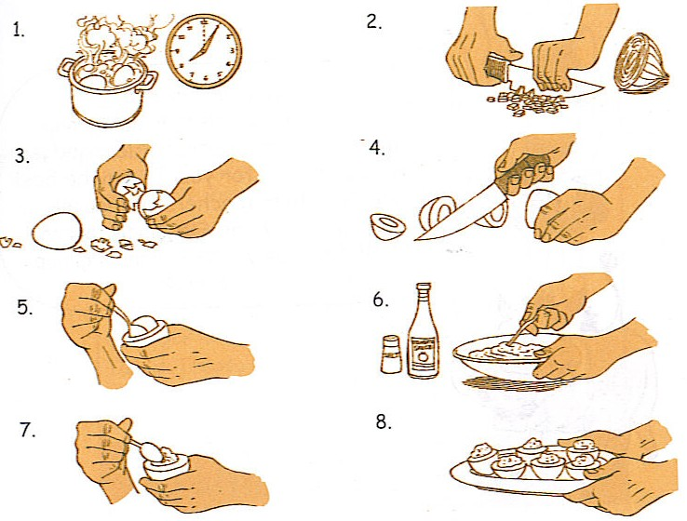

QUESTION 5 DESIGNING A POSTER
Posters are effective ways of giving information. Design and make a poster about eating disorders. Choose one idea to communicate. Use colour, and effective lettering.

(20)

